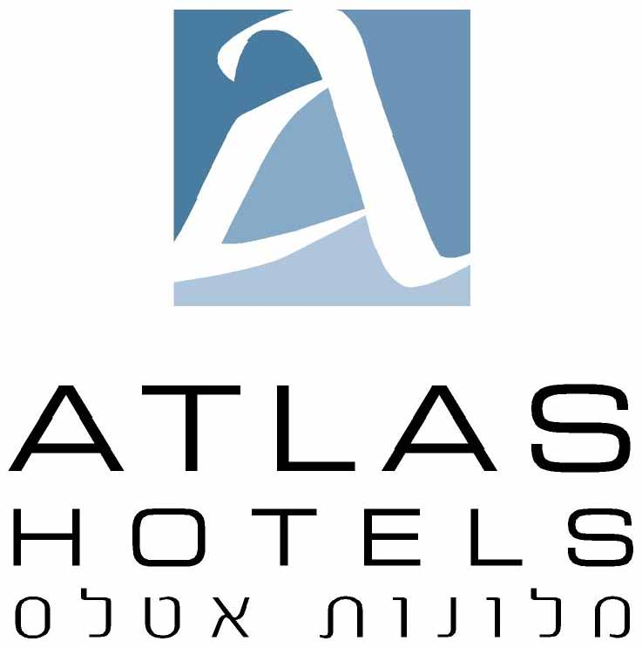

287 Hayarkon St, Tel Aviv 63504 Israel Tel: 972-3-5425560, Fax: 972-3-7608920 E-mail : avi@atlashotels.co.il

DATE: | July 28, 2026 | REF: | 21507
ATTENTION: | Reservations – Avi Cohen
weizmann

HOTEL:
Room type:
Single:
Double:
Guest name :
Arrival date:
Check-in 14:00:
Departure date
Check-out 12:00
Credit card details for the guarantee: | №:
 | Expiration date: ____ / ____
Card holder’s name
(if different than guest name)
Passport number of card holder:
Contact information (tel / email) :

